Human Impacts on Our Coastal Ecosystem
Ocean Imbalance

Time: 35 minutes
Group Size: 10-15 students
Grade Levels: 9th – 12th grade
Location: Maddie James Seaside Learning Center - Citizen Science Lab

OVERVIEW OF ACTIVITY

Students will explore the effects of eutrophication while conducting hands on water quality testing and analyzing results. Students will test and record the nutrient levels (nitrate and phosphate), dissolved oxygen, pH, and temperature from three different water samples. Water samples will include a control sample and two additional samples (Sample A and B) with increasing amounts of liquid fertilizer to model how humans are impacting our coastal ecosystem through increased agricultural runoff attributed to population growth. After recording data and discussing results, students will continue their investigation by briefly discussing the moon jelly life cycle and anatomy to gather information as to their adaptability to a changing marine environment. A video will demonstrate a “jelly invasion” so that students can develop a hypothesis on what makes it possible for jellies to appear from “out of nowhere,” producing large population blooms.

PERFORMANCE OBJECTIVES

Students will be able to:
- Successfully identify and use test equipment to accurately record and analyze data taken from water samples.
- Use graph to interpret data collected from abiotic tests.
- Compare and contrast the data collected between samples and establish how abiotic factors influence each other. (Do the nitrate and phosphate levels affect the DO levels?)
- Make inferences between the data collected for nitrate, phosphate and DO and the effects it may have on an ecosystem.
- Use data collected from water chemistry and information gathered on jellies to infer their adaptability to a changing marine environment.
- Hypothesize why the impacts of eutrophication have enabled jellies to thrive while other marine animals have met their demise.

CHALLENGE

Conduct water chemistry tests to collect data and make connections between the varying amounts of liquid fertilizer and the abiotic factors (nitrate, phosphate, DO, pH, and temperature) being tested.

MATERIALS

- Probes for DO, pH, and Temperature Tests*
- Blue Pasco sensors*
- Surface tablets with Spark Vue to record data*
- Test Kits for Nitrate and Phosphate tests
- Test procedure cards for nitrate and phosphate
- Distilled Water
- Rinse water beaker with distilled water (to keep probes in)
- Syringe (to take out sample water for test kits)
- Waste buckets and extra towels
- Water sample containers - Control, Sample A, Sample B
- Whiteboard with data table
- Metal stands for tablets
- Extra tablet with 1:30 video clip loaded on jelly invasion-
http://www.youtube.com/watch?v=eyCigZ_bsTM

*technological components are stored upstairs at science cubicle

ADVANCE PREPARATION

- Log in to tablet (password 6264) and open SparkVue software. Check to make sure sensors and probes are working properly - there will be a number next to the test. If it is at 0, try unplugging the probe and plugging it back in. You can also turn the sensor off and on to reset all the probes.
- In SparkVue, go to “Saved Work”, click and open file “oceanimbalance.spk2.spklab.” Skip slides to get to the graph and instructions for using probes (slide #5). Leave it on this slide to start the station.
- Clean and set out whiteboard, waste buckets, and a couple of towels.
- Set out nutrient test kits, probes, rinse water beakers with distilled water, and procedure cards.
- Leave out extra tablet and click “Jelly Video” located on the desktop. Pause the video and have it ready to go for the station.

TEACHING TIPS
- Present the teams with their challenge. Rotate between teams to help students who need additional assistance and focus on the students who get off task. Ensure students work on good sampling and measuring techniques.
- Have students conduct the nitrate and phosphate tests first and then stop them to provide instruction on the sensor and probe procedures.
- Direct students to the instructions on the tablet screen and make sure they are following directions thoroughly and completely.
- Encourage students to build on the data and information gathered during water chemistry and video clip to help develop their hypothesis.
- One of the objectives of this station is to teach students that increased levels of nitrates and phosphates will result in lower to no levels of dissolved oxygen in the water as a result of eutrophication. Data that students collect will not always reflect this. This is a great opportunity to speak to students about how science works and how scientists use data.

PROCEDURE

Engage: (5 min):
- Students will be addressing the issue of eutrophication in this station by testing the abiotic factors of three water samples containing varying degrees of liquid fertilizer. The abiotic factors being measured are nitrates, phosphates, DO, pH and temperature.
- Our challenge is to determine how the varying amounts of fertilizer will affect these abiotic factors.
- Tell students there are three water samples: Control (0 drops fertilizer), Sample A (40 drops fertilizer), and Sample B (80 drops fertilizer).
- Ask students some questions to encourage critical thinking:
  - What is a control and why is using a control sample an important scientific practice? (A control in a scientific experiment isolates the variable that is being tested. This provides baseline data that can be compared to the results of other samples.)
  - Why do we use fertilizer and what nutrients does it contain? (It contains nitrates and phosphates which stimulate plant growth.)
  - What is being modeled in this experiment? (The impact of runoff on the water quality in Dana Point Harbor, which is an area highly impacted by human activity.)
  - How does the use of fertilizers impact our coastal water? (Increased fertilizer use for agriculture leads to increased runoff from land to coastal waterways.)
  - What could the subsequent effects on coastal ecosystems? (This experiment will help us to determine effects of eutrophication.)

Explore (25 min):
- Divide the group into three smaller groups and assign each group to a water sample.
- Control: 4 liters harbor water- algae- sand- No added fertilizer (Control Group)
- Sample A: 4 liters harbor water- algae- sand- 40 drops fertilizer added
- Sample B: 4 liters harbor water- algae- sand- 80 drops fertilizer added
- Tell students to start on the nitrate and phosphate tests first because there is wait time for results. Then while waiting on the results they can start on the DO, pH and temperature tests with the probe-ware.
- Explain to students the instructions for the sensors and probes are displayed on the tablet screen. Note: students typically need extra assistance during this portion – make sure to facilitate as much as you can once students are finished with the nitrate and phosphate tests.
- After completing the tests, students should record their results on the student sheet as well as the whiteboard.

Explain (7 min):
When all of the results have been recorded, discuss the following questions with the students:

- How did the abiotic factors change in relation to the amount of fertilizer?

- Looking at your group’s data, were any of the results unexpected? (Data can vary greatly in each sample. Encourage students to come up with an explanation for their results that may reflect samples being in different phases of the bloom cycle, nutrients being used up by algae, etc.)

- Are nutrients, such as nitrates and phosphates, in the water naturally? (Yes. Point out what a normal range for nitrate and phosphate is and explain how these nutrients can naturally occur in the water- animal waste, decomposition, breakdown of rocks, etc.)

- How can nutrients enter the water unnaturally? (Fertilizers, as seen in these samples, as well as soap, detergents, and other pollution.)

- How are fertilizers entering our coastal waters? (When water runs off the land, via the water cycle, extra nutrients from fertilizers or other chemicals enter the water. This excess of nutrients in water is called eutrophication.)

- How is algal growth affected by increased levels of nitrates and phosphates? (Increased nutrients allow for more algal growth initially. Keep in mind that students’ nutrient and DO data will not always correlate perfectly with what is expected in their samples.)

- If algal growth increases due to nutrient rich environments, what may also increase? (Initially it will cause an increase in food supply for zooplankton and increase oxygen.) What may happen after the algal growth dies out? (As the bloom of phytoplankton and algae dies off, organisms fall to the seafloor to be decomposed by bacteria, which utilize all available oxygen and will create hypoxic or anoxic environments, called “dead zones.”)

- What is eutrophication? (It is the process by which a body of water acquires a high concentration of nutrients, especially phosphates and nitrates.)

- Why are abiotic factors important to an ecosystem? What happens if these factors change too rapidly? (All animals are adapted to survive within a specific range of environmental conditions. Animals can go into distress if the abiotic factors change rapidly.)

- What may happen to a marine ecosystem after continual degradation due to eutrophication? (Some species cannot acclimate to these changes and may become extinct while others thrive.)

- Permanent dead zones have been formed in some areas of the world, like the Gulf of Mexico. What would cause these areas to become permanently hypoxic? What economic effects could it have? (Extreme eutrophication in the Gulf is the result of runoff from the Mississippi River which runs through large areas of farmland and other areas impacted by humans. Many fishermen rely on fish and shrimp in the Gulf to earn a living, so this dead zone could affect the economy in states with large fishing industries.)

Extend: Show the students the jelly video (on the tablet) and ask the following questions:
- How would large numbers of jellies affect the ecosystem of an area? (One way is that large numbers of jellies can outcompete other animals for food and alter the food chain.)

- How can humans impact the likelihood of a jelly bloom? (Yes, scientists are not in agreement to what extent humans are causing changes in the ocean, but most agree we are having some impact. Climate change, overfishing, and pollution are some human impacts.)

- Why might more jelly blooms be happening? (Possible answers: natural cycles in the ocean, human-caused climate and environmental changes, i.e. increased agriculture leads to fertilizer runoff and eutrophication, an issue that is expounded by population increases since the Industrial Revolution.)

- What steps can humans take to reduce or mitigate the environmental and economic effects of eutrophication? (Answers will very, can include solutions like long-term monitoring, water treatment, regulations on agriculture, etc.)

- Take students to Tank Farm to view different jelly life cycles and observe anatomy.

Evaluate (3 min): Discuss the following questions with the students:

- If you could run your tests again, what would you do differently? How do scientists minimize errors in data collection? What other abiotic factors could you test?

- What solutions can you offer to prevent eutrophication from occurring?

- How does ocean imbalance specifically affect you as an individual?

RECOMMENDED ASSESSMENT STRATEGY
Use the discussion questions and the number and type of questions asked and answered to assess student knowledge. Additionally, you can follow the student worksheet as a guideline when discussing results to help students follow along. Make sure that students’ responses to questions correspond to the answers provided.

ACTIVITY RESOURCES

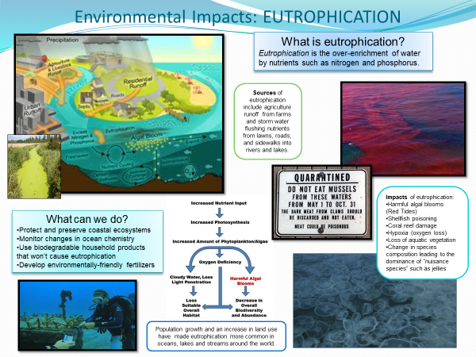

Ocean Imbalance Data Board
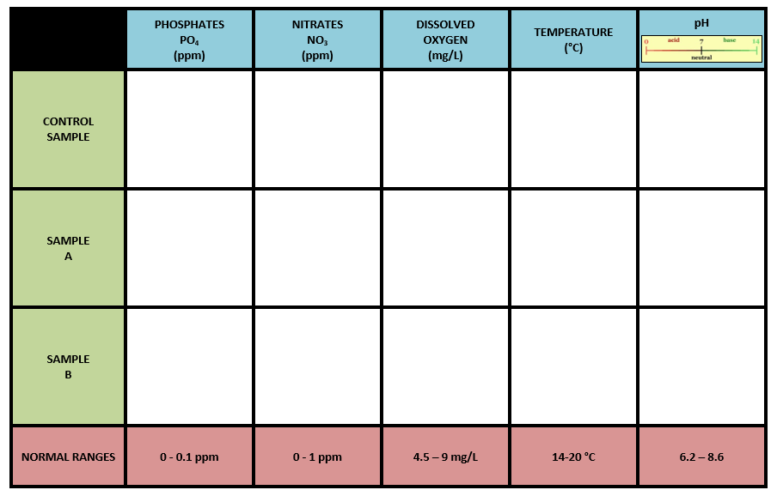
Ocean Imbalance PowerPoint (in SparkVue on tablet)
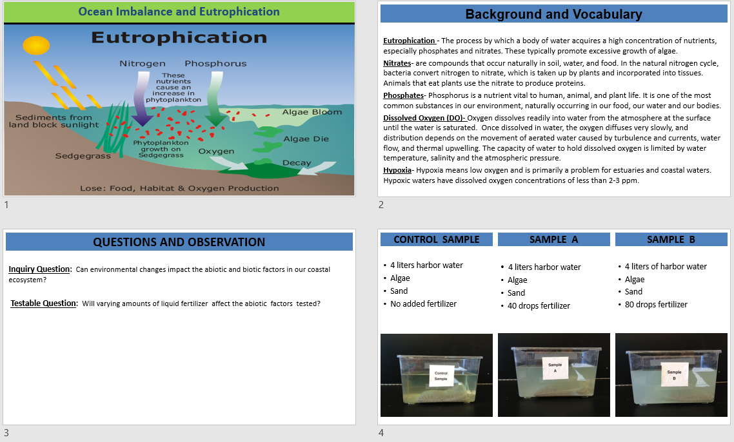
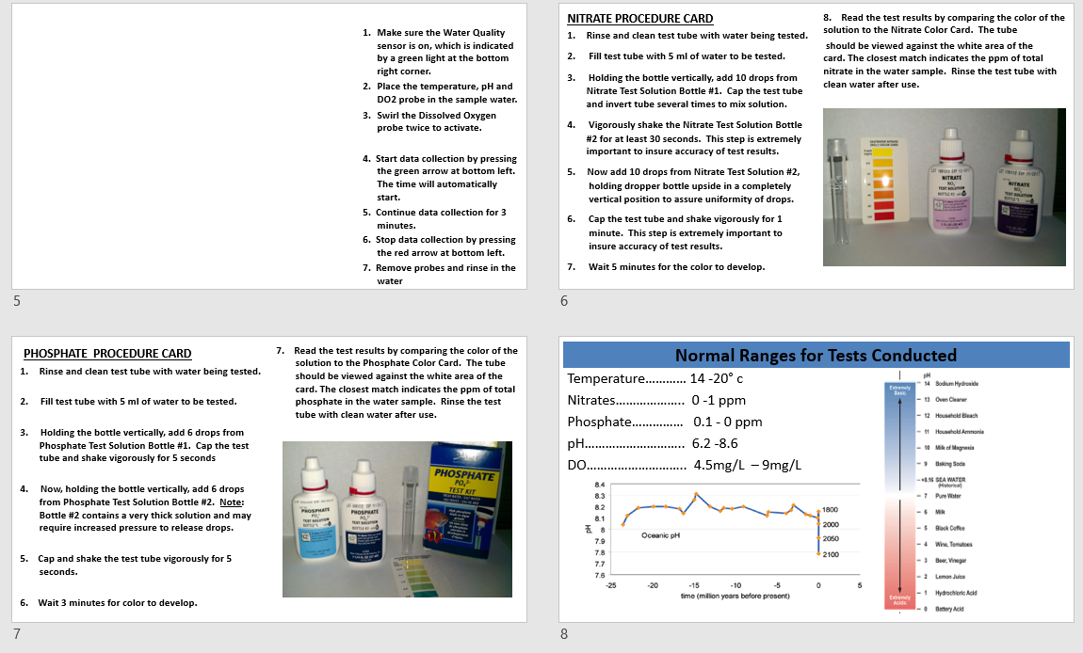
BACKGROUND INFO

The word eutrophication has its root in two Greek words “eu” which means well and “trope” which means nourishment. The modern use of eutrophication is related to inputs and effects of nutrients in aquatic systems. Within the past 50 years, eutrophication has emerged as one of the leading cause of water quality impairment. Two of the most important nutrients responsible for eutrophication are nitrogen and phosphorus. In freshwater environments phosphorus is usually the nutrient in the lowest concentration and therefore generally limits the growth of phytoplankton. In coastal environments nitrogen usually limits the growth of phytoplankton because it is generally the nutrient in the lowest concentration. Nitrogen is commonly found in aquatic environments as nitrate (NO₃⁻), nitrite (NO₂⁻) or ammonia (NH₄⁺). Phosphorous is also commonly found in the form of phosphate (PO₄³⁻).

The sources of eutrophication have increased in the past 50 years. Urban development and the Industrial Revolution have introduced municipal wastewater treatment plants, industrial wastewater discharges, nitrogen leaching from below-ground septic tanks, and storm water runoff. Increased fertilizer usage and subsequent agricultural runoff from farm fields is one of the primary sources of increased nutrients in many coastal waterways. The burning of fossil fuels releases nitrogen oxides into the atmosphere which contributes to the formation of smog and acid rain. This is then redeposited to land and water through rain and snow. Aquaculture (fish farming) is another growing source of nutrient pollution. These farms generate concentrated amounts of nitrogen and phosphorus from excrement, uneaten food, and other organic waste. If improperly managed, aquaculture operations can have severe impacts on aquatic ecosystems as nutrient wastes are discharged directly into the surrounding waters.
As a result of the excess nutrients in our coastal waterways algal blooms have increased. Harmful algal blooms are usually produced under eutrophic or hypereutrophic conditions. Cyanobacteria and dinoflagellates are examples of phytoplankton responsible for surface scum, oxygen depletion, and consequent fish kills. Low dissolved oxygen concentration, or hypoxia, can result from the decomposition of dead phytoplankton. As bacteria break down and decompose the phytoplankton, they take up dissolved oxygen. Dissolved oxygen is essential to many organisms living in aquatic environments; therefore, a decrease in dissolved oxygen concentrations could affect many aquatic organisms. Changes in the abundance and species composition of phytoplankton could change the quality of food available to higher trophic level organisms. In addition, blooms of phytoplankton can reduce the amount of light available to organisms and plants beneath the surface layer. Submerged aquatic vegetation (SAV) can be very sensitive to changes in water clarity. Phytoplankton blooms often make the surface layer very turbid and attenuate light. Light attenuation is the decrease in light intensity resulting from absorption of energy and of scattering due to particles (such as phytoplankton) in the water.

Therefore, severe eutrophication could affect growth of submerged aquatic vegetation. A decrease in SAV can cause a shift in the species composition due to the important role they play as nursery habitats and refuges for many aquatic organisms. Additionally, changes in species composition and biomass of the benthic aquatic community eventually lead to reduced species diversity and the dominance of gelatinous organisms such as jellies. Finally, increased nutrient levels favor algae growth over coral larvae. Coral growth is inhibited because the algae outcompetes coral larvae for available surfaces to grow.

The management and control of cultural eutrophication is closely related to the prevention and control of pollution. Many state and federal agencies monitor surface and groundwater quality with the goal of preventing severe eutrophication. Dissolved oxygen, pH, nutrients, and chlorophyll a are just a few of the water quality parameters that are often monitored. There are many things that as individuals we can do to help prevent human induced eutrophication. Reducing the use of lawn fertilizers and purchasing household detergents and cleaners with low phosphorus concentrations are just two actions that could help control of cultural eutrophication.
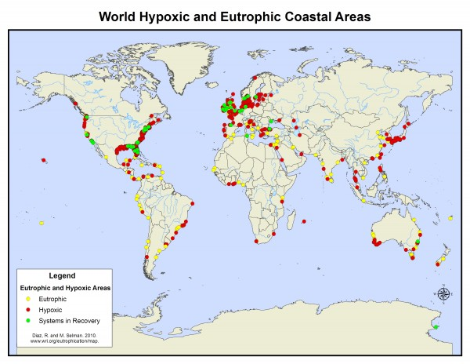
Jelly Invasion: A Primeval Tide of Toxins

Runoff from modern life is feeding an explosion of primitive organisms. This 'rise of slime,' as one scientist calls it, is killing larger species and sickening people.

By Kenneth R. Weiss, Times Staff Writer
July 30, 2006
In many places — the atolls of the Pacific, the shrimp beds of the Eastern Seaboard, the fjords of Norway — some of the most advanced forms of ocean life are struggling to survive while the most primitive are thriving and spreading. Fish, corals and marine mammals are dying while algae, bacteria and jellyfish are growing unchecked. Where this pattern is most pronounced, scientists evoke a scenario of evolution running in reverse, returning to the primeval seas of hundreds of millions of years ago.
Jeremy B.C. Jackson, a marine ecologist and paleontologist at the Scripps Institution of Oceanography in La Jolla, says we are witnessing "the rise of slime."

Even in modern times, when oil spills, chemical discharges and other industrial accidents heightened awareness of man's capacity to injure sea life, the damage was often regarded as temporary. But over time, the accumulation of environmental pressures has altered the basic chemistry of the seas. The causes are varied, but collectively they have made the ocean more hospitable to primitive organisms by putting too much food into the water. Industrial society is overdosing the oceans with basic nutrients — the nitrogen, carbon, iron and phosphorous compounds that curl out of smokestacks and tailpipes, wash into the sea from fertilized lawns and cropland, seep out of septic tanks and gush from sewer pipes. Modern industry and agriculture produce more fixed nitrogen — fertilizer, essentially — than all natural processes on land. Millions of tons of carbon dioxide and nitrogen oxide, produced by burning fossil fuels, enter the ocean every day. These pollutants feed excessive growth of harmful algae and bacteria. At the same time, overfishing and destruction of wetlands have diminished the competing sea life and natural buffers that once held the microbes and weeds in check.
The consequences are evident worldwide. We're pushing the oceans back to the dawn of evolution," Jackson said, "a half-billion years ago when the oceans were ruled by jellyfish and bacteria."
Jellyfish populations are growing because they can. The fish that used to compete with them for food have become scarce because of overfishing. The sea turtles that once preyed on them are nearly gone. And the plankton they love to eat are growing explosively. The ancient seas contained large areas with little or no oxygen — anoxic and hypoxic zones that could never have supported sea life as we know it. It was a time when bacteria and jellyfish ruled. Robert Diaz, a professor at the Virginia Institute of Marine Science, has been tracking the spread of low-oxygen zones. He has determined that the number is nearly doubling every decade, fed by a worldwide cascade of nutrients — or as he puts it, energy. We stoke the ocean with energy streaming off the land, he said, and with no clear pathways up the food chain, this energy fuels an explosion of microbial growth.

Read the full article here:
http://www.latimes.com/world/la-me-ocean30jul30-story.html

Eutrophication
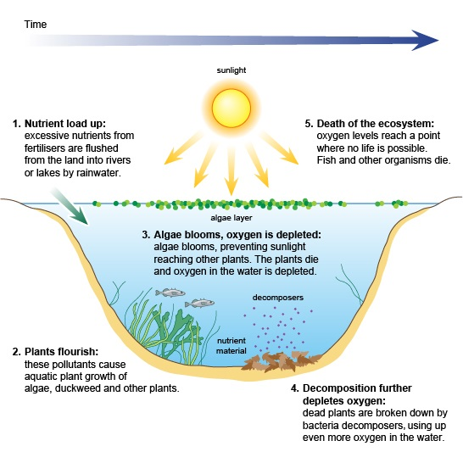

VOCABULARY
- Eutrophication - “The process by which a body of water acquires a high concentration of nutrients, especially phosphates and nitrates. These typically promote excessive growth of algae. As the algae die and decompose, high levels of organic matter and the decomposing organisms deplete the water of available oxygen, causing the death of other organisms, such as fish. Eutrophication is a natural, slow-aging process for a water body, but human activity greatly speeds up the process.” - Art, 1993
- Abiotic – (opposite to biotic) non-living, a term used for characteristics and elements of the environment that influence the survival or reproduction of organisms but are not alive themselves. Examples are temperature, light, nutrients, etc.
- Biotic – living, term used to describe the elements within an ecosystem that interact with abiotic factors.
- pH – “power of hydrogen"; scale from 0 – 14 that measures the concentration on hydrogen-ions in a substance. A pH range from 0 – 7 means the substance is acidic (tomatoes, battery acid), a value of 7 means the substance is neutral, and 7 – 14 means the substance is basic or alkaline (lye, detergent, soap). Sea water has a pH value of approximately 7.8 – 8.2.
- Nitrogen Cycle: Animals that eat plants use nitrogen to produce proteins. Nitrogen is returned to the environment in animal feces, as well as through microbial degradation of plants and animals after they die. Microorganisms can convert nitrate to nitrite; this reaction occurs in the environment as well as within the digestive tract of humans and other animals. After bacteria convert (reduce) nitrate to nitrite in the environment, the nitrogen cycle is completed when they then convert the nitrite to nitrogen.
- Nitrates- compounds that occur naturally in soil, water, and food. In the natural nitrogen cycle, bacteria convert nitrogen to nitrate, which is taken up by plants and incorporated into tissues. Animals that eat plants use the nitrate to produce proteins. Nitrate is returned to the environment in animal feces, as well as through microbial degradation of plants and animals after they die. Microorganisms can convert nitrate to nitrite; this reaction occurs in the environment as well as within the digestive tract of humans and other animals. After bacteria convert (reduce) nitrate to nitrite in the environment, the nitrogen cycle is completed when they then convert the nitrite to nitrogen. Normally, this natural cycling process does not allow excessive amounts of nitrates or nitrites to accumulate in the environment. However, human activities have increased environmental nitrate concentrations, with agriculture being the major source. This includes increased use of nitrogen-containing fertilizers as well as concentrated livestock and poultry farming; the latter two produce millions of tons of nitrate-containing manure each year. Nitrate and nitrite compounds are very soluble in water and quite mobile in the environment. They have a high potential for entering surface water when it rains, as nitrates in applied fertilizers can dissolve in runoff that flows into streams or lakes; they also have a high potential for entering groundwater through leaching. Unpolluted waters generally have a nitrate-nitrogen level below 1 ppm. Nitrate-nitrogen levels above 10 ppm are considered unsafe for drinking water.
- Phosphates- come from industrial effluent and detergent wastewater from residences and can leach from natural deposits. Phosphorus occurs in natural waters in the form of phosphates. Organically bound phosphates in water come from plant and animal matter and wastes. Phosphates are nutrients that can be dissolved in water. Measuring the phosphate levels in a water sample can be an indicator of pollution levels and water health. Phosphate levels are measured in parts per million, abbreviated ppm. Total phosphorus levels higher that 0.03 ppm can contribute to increased plant growth. Total phosphorus levels above 0.1 ppm may stimulate plant growth sufficiently to surpass natural plant growth rates.
- Hypoxia- Hypoxia means low oxygen and is primarily a problem for estuaries and coastal waters. Hypoxic waters have dissolved oxygen concentrations of less than 2-3 ppm.
- Light attenuation- is the decrease in light intensity as a result of absorption of energy and of scattering due to particles (such as phytoplankton) in the water.
- Dissolved Oxygen (DO)-Aquatic organisms, like terrestrial organisms, need dissolved oxygen to survive. Fish, invertebrates, plants, and aerobic bacteria all require oxygen for respiration. Oxygen dissolves readily into water from the atmosphere at the surface until the water is saturated. Once dissolved in water, the oxygen diffuses very slowly, and distribution depends on the movement of aerated water caused by turbulence and currents, water flow, and thermal upwelling. Aquatic plants (algae and phytoplankton) produce oxygen as a by-product of photosynthesis. The capacity of water to hold dissolved oxygen is limited by water temperature, salinity and the atmospheric pressure. These factors determine the highest DO level possible, even in well-aerated water.
Baselines:
- Temperature: 14-20° Celsius (Source: National Oceanic Data Center)
- pH: 6.5-8.2 (Source: LaMotte Chemical Corporation)
- Salinity: 33-37ppt (Source – National Weather Service)
- Dissolved Oxygen: 5-8ppm (Source: International Project Wet, Montana State University)
5–6 ppm: Sufficient for most species
<3 ppm: Stressful to most aquatic species
<2 ppm: Fatal to most species
- Nitrates: 1ppm (Source: USGS National Water Quality Assessment Program 2005)
- Nitrites: 0.1ppm (Source: Red Sea Test Kit Corporation)
- Phosphates: 0.1ppm (Source: LaMotte Chemical Corporation)

Helpful Resources
Information on Eutrophication
http://www.eoearth.org/article/Eutrophication
http://www.wri.org/project/eutrophication/about
http://www.bigelow.org/edhab/building_bloom.html

Pre-Trip information and investigation
http://www.bottlebiology.org/investigations/terraqua_main.html

Video used for intro into Jelly station
http://www.youtube.com/watch?v=eyCigZ_bsTM

Jelly Facts site
http://www.jellyfishfacts.net/jellyfish-problems.html
http://www.eurocbc.org/page727.html

